General MAP Awareness Post:

Did you know that <insert church name> offers members access to free, professional counseling services through the Member Assistance Program (MAP) with Christian Family Solutions?

If you’ve been feeling overwhelmed, stuck, or just need someone to talk to, you don’t have to handle it alone.

Reach out to the church office to learn more or request a referral. We’re here for you!

Image to go with…
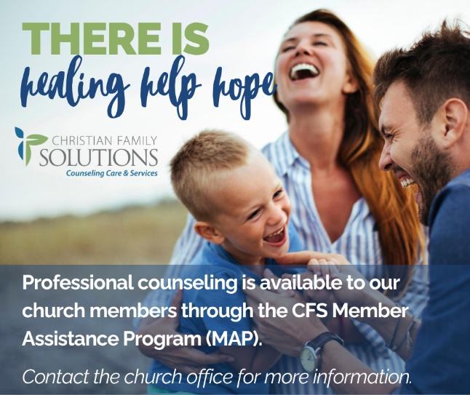

Post for Mental Health Awareness Month:

Mental Health Awareness Month in May is a reminder that every person carries a story, and no one is meant to walk through life’s challenges alone. As followers of Christ, we’re called to see one another with compassion and care, to listen, and to support one another through every season.

If you or someone you love is struggling, help is available.

Our church is part of Christian Family Solutions’ Member Assistance Program (MAP), which gives you access to free professional counseling sessions.

Taking a step toward support is not a sign of weakness. It’s part of caring for the life God has given you.

Reach out to the church office to learn more or request a referral. We’re here for you!

Image to go with…
